PROJECT REPORT

AI/ML-Based Application – AI Cricket Batting Analyzer

Submitted By
Name: Gaurank yadav
Course: BCA
Semester: 5th Semester
Roll No.: 24116004404
College: Great Ganges Institute of Technology,Gadankhera,unnao
University:Chhatrapati Shahu ji Maharaj Unniversity Kanpur

1. INTRODUCTION
Cricket is a very popular sport. In cricket, a batsman's body position is very important.
A player needs good balance, correct head position, proper shoulder position and good leg movement while batting.
AI Cricket Batting Analyzer is a simple project that helps to check these things using a cricket batting video.
In this project, the user uploads a batting video. The system checks the player's body position and shows the body with dots and lines.
It also gives some basic information about the player's head, shoulders, knees and body balance.
The main purpose of this project is to make basic batting analysis easy.

2. PURPOSE OF THE PROJECT
The main purpose of this project is to analyze a cricket batting video using a computer.
Normally, a player may need a coach to watch the video and give feedback.
This project tries to give some basic feedback automatically.
It can help a player understand:
- How the head is moving.
- How the shoulders are positioned.
- How the knees are positioned.
- How the body balance looks.

3. OBJECTIVES
The main objectives of this project are:
- To upload a cricket batting video.
- To detect the player's body.
- To show body points using dots.
- To show body connections using lines.
- To check basic body position.
- To check head movement.
- To check shoulder position.
- To check knee position.
- To check body balance.
- To give simple suggestions.
- To create an analyzed video.

4. HOW THE PROJECT WORKS
The project works in a simple way.
First, the user opens the AI Cricket Batting Analyzer.
Then the user uploads a cricket batting video.
The system reads the video and checks it frame by frame.
It finds the important points of the player's body.
These points are shown as dots and lines on the video.
After that, the system checks some basic body positions like:
- Head
- Shoulders
- Knees
- Body balance
Finally, the system gives some basic suggestions and creates an analyzed video.
The analyzed video can be watched in the browser.

5. TECHNOLOGIES USED

Python
Python is the main language used to make this project.
The main program of the project is written in Python.

Streamlit
Streamlit is used to make the simple screen of our project.
It allows the user to:
- Open the project in a browser.
- Upload a video.
- Start the analysis.
- See the results.
- Watch the analyzed video.
So, we can say that Streamlit makes the user interface of the project.

OpenCV
OpenCV is used to work with the video.
It helps the program to:
- Open the video.
- Read the video frame by frame.
- Process the video.
- Put dots and lines on the video.
- Create the final video.
In simple words, OpenCV helps us work with the video.

MediaPipe
MediaPipe is one of the most important parts of this project.
It helps the program find different points of a person's body.
For example:
- Head
- Shoulders
- Hands
- Hips
- Knees
- Feet
These points help us understand the player's body position.
In simple words, MediaPipe helps us detect the human body in the video.

NumPy
NumPy is used for simple mathematical calculations.
It helps us work with the numbers and positions received from the body detection.
For example, it helps in checking movement, angles and other values.

FFmpeg
FFmpeg helps us create a video that can play properly in the browser.
The processed video is converted into a suitable MP4 format.
In simple words, FFmpeg helps make the final video playable.

6. BODY DETECTION
The project detects different points of the player's body.
For example:
●
Head
|
●────●────●
Shoulder Shoulder
\ /
\ /
●
Hip
/ \
● ●
Knee Knee
| |
● ●
Foot Foot
The dots show the body points.
The lines connect these points.
This makes it easy to see the player's body position.

7. BATTING ANALYSIS
The project checks some basic things about the player's body.

Head
The project checks the movement of the head.
It gives basic feedback about whether the head movement looks controlled.

Shoulders
The project checks the position of both shoulders.
It gives basic information about shoulder position.

Knees
The project checks the position of the knees.
It also uses the body points to calculate basic knee angles.

Body Balance
The project checks the position of the body and feet.
It gives a basic idea about the player's body balance.

8. AI SUGGESTIONS
After checking the player's body position, the project gives simple suggestions.
For example:
- Head movement looks good.
- Shoulder position looks good.
- Knee position needs improvement.
- Body balance needs improvement.
These suggestions are based on the values calculated by the program.
The project uses simple rules to give these suggestions.

9. VIDEO ANALYSIS
The video is checked frame by frame.
For example:
Video
↓
Frame 1
↓
Frame 2
↓
Frame 3
↓
Frame 4
↓
Body Detection
↓
Analysis
↓
Final Video
The body points and lines are added to the frames.
All the processed frames are then joined together to create the final analyzed video.

10. FEATURES OF THE PROJECT
The main features are:
- Easy video upload.
- Simple browser interface.
- Body point detection.
- Body lines detection.
- Head movement checking.
- Shoulder checking.
- Knee checking.
- Body balance checking.
- Basic suggestions.
- Analyzed video.
- Video download option.

11. ADVANTAGES
This project has some simple advantages:
- It is easy to use.
- The user only needs to upload a video.
- It shows the player's body clearly.
- It gives basic batting feedback.
- It can be used by beginners.
- It can help in understanding body posture.
- The analyzed video can be saved and watched later.

12. FUTURE SCOPE
This project can be improved in the future.
Some new features can be added, such as:
- Cricket bat detection.
- Cricket ball detection.
- Shot detection.
- Footwork analysis.
- Bat movement analysis.
- Bat speed calculation.
- Ball speed calculation.
- More detailed batting suggestions.
- Player performance history.
For example, in the future the system could identify whether the player played a cover drive, pull shot, cut shot or straight drive.

13. PROJECT REQUIREMENTS

Hardware
- Laptop or computer
- Minimum 4 GB RAM
- Enough storage space

Software
- Windows
- Python
- VS Code
- Streamlit
- OpenCV
- MediaPipe
- NumPy
- FFmpeg
- Web browser

14. PROJECT WORKING IN SIMPLE WORDS
The complete project can be understood in these steps:
Step 1: Open the AI Cricket Batting Analyzer.
Step 2: Upload a cricket batting video.
Step 3: The program reads the video.
Step 4: MediaPipe finds the player's body points.
Step 5: OpenCV puts dots and lines on the video.
Step 6: The program checks the head, shoulders, knees and balance.
Step 7: The program gives basic suggestions.
Step 8: A new analyzed video is created.
Step 9: The analyzed video is shown in the browser.

15. CONCLUSION
The AI Cricket Batting Analyzer is a simple project made using Python and computer vision.
It takes a cricket batting video and checks the player's body position.
The project uses MediaPipe to detect body points and OpenCV to process the video.
It shows the body using dots and lines and gives basic information about the head, shoulders, knees and body balance.
The project is useful for learning how computer vision can be used in sports.
In the future, more cricket features can be added to make the project more advanced.

16. REFERENCES
- Python
- OpenCV
- MediaPipe
- Streamlit
- NumPy
- FFmpeg

17. PROJECT SCREENSHOTS

Project Home Page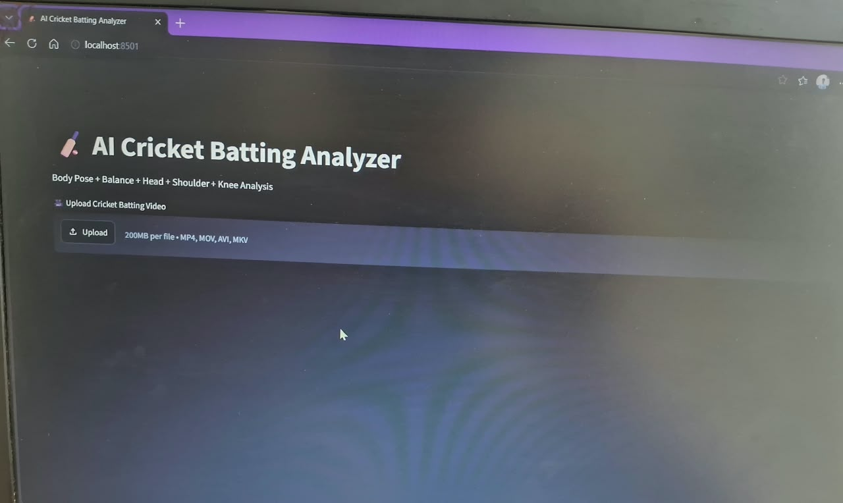

Body Detection with Dots and Lines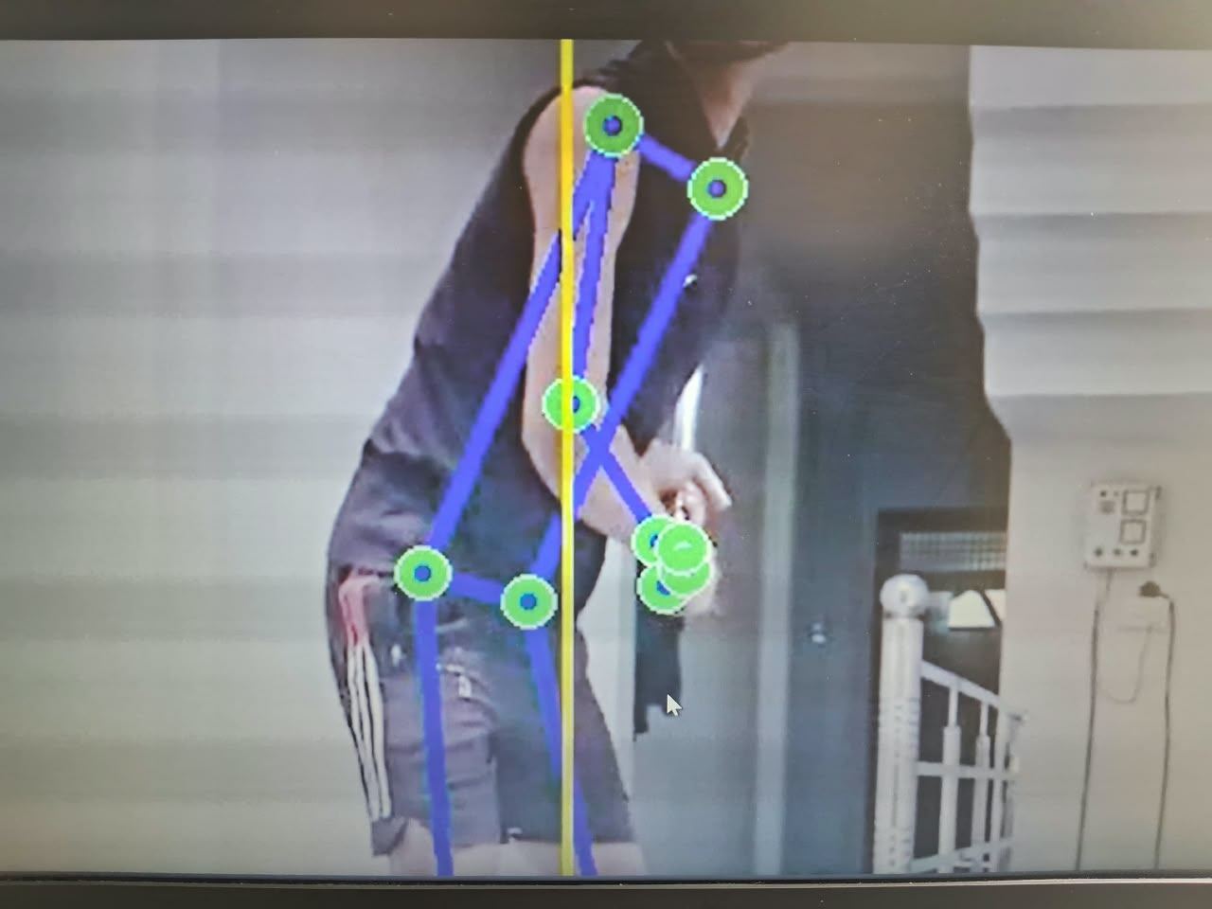

Analysis Result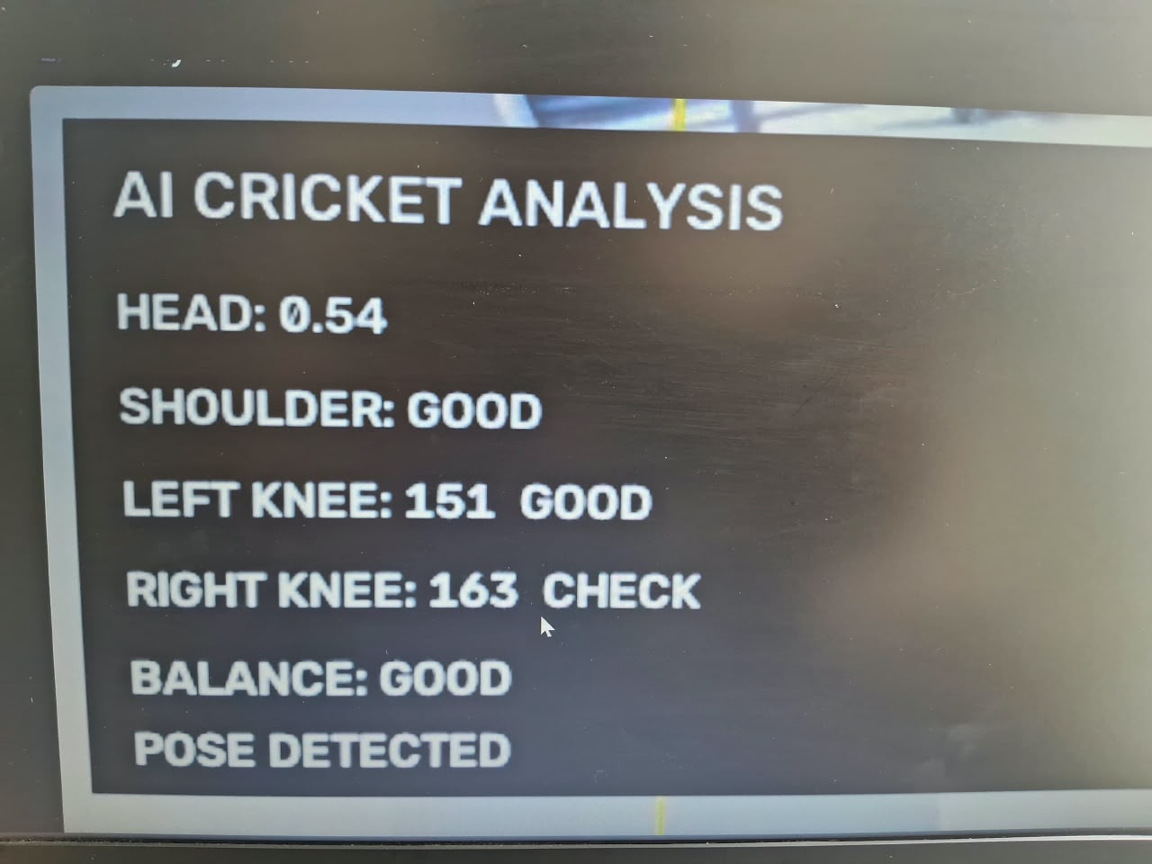

Suggestions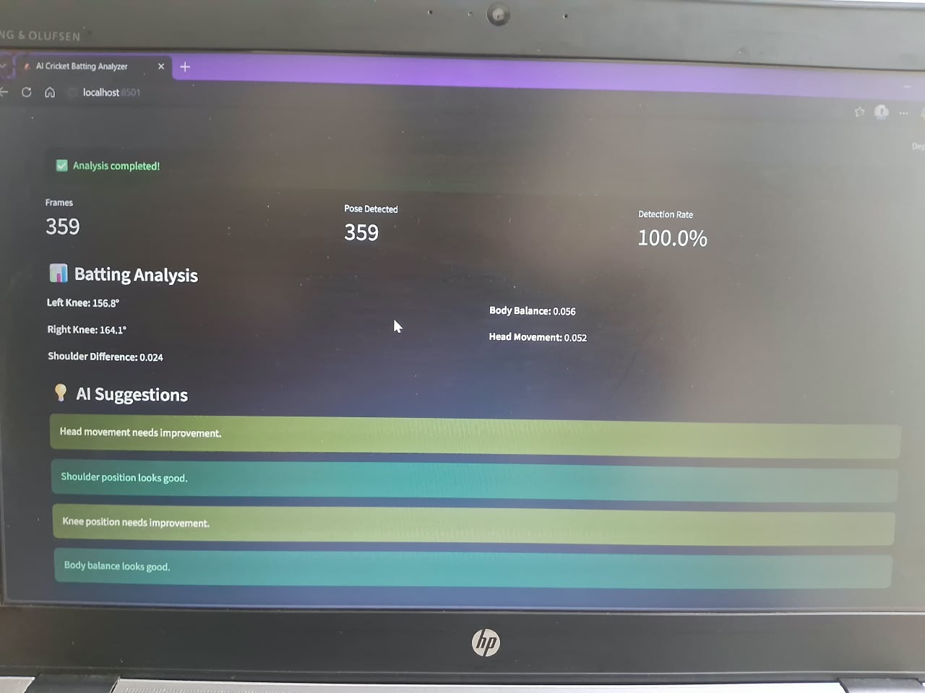

Download Video